Biometric Attendance System Over IOT
Here we propose a smart fingerprint based biometric attendance system that works over IOT so that attendance can be monitored from anywhere in the world. Our system uses a microcontroller based circuit with fingerprint sensor, push buttons, power supply, power supply and wifi modem to interact with internet based system. We here use IOTGecko to develop the online attendance display system. Our system allows users/employees/students to first register their fingerprint on the system. After successful registration the print is stored in system with class assigned using push buttons. The system also displays these details over LCD display. Now as soon as the next time a registered user scans the modem, the system checks for authentication and authenticated users data is transferred online to IOTGecko using the gecko development API codes. Now the online system stores and displays the required data to users as per online login. Thus our system allows for remote monitoring of biometric based attendance from anywhere over IOT.

Block Diagram :
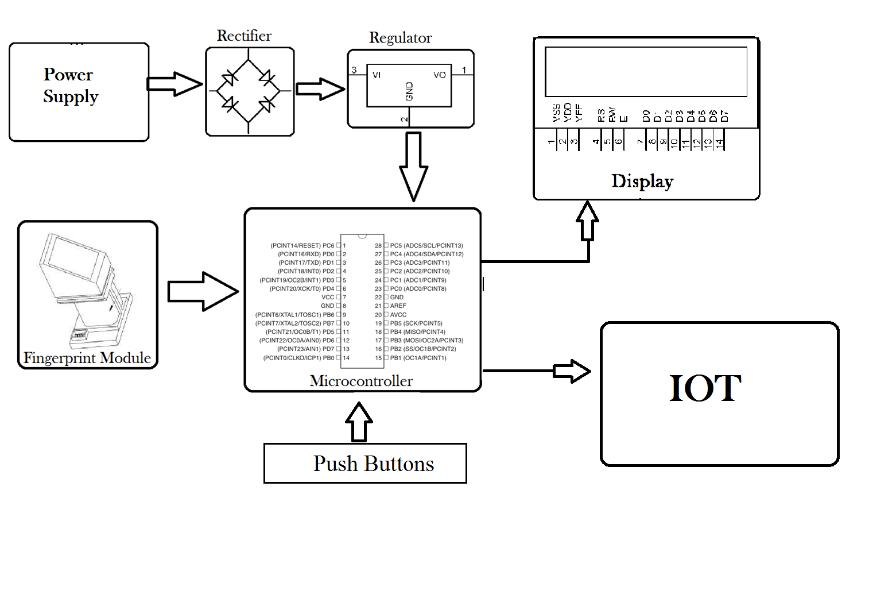

Hardware Specifications
- Power Supply
- Rectifier
- Regulator
- LCD Display
- Fingerprint Module
- Atmega Microcontroller
- Push buttons
- Wifi Modem
- Resistors
- Capacitors
- Diodes
Software Specifications
- Python compiler
- Programming Language: Python
- IOTGecko

